Data Structures Lab Assignment ODD 2022

**Week 9 Lab A**

Q1) Create a multi-list using C language. Now, Given the head of the first level of the list, Flatten the list so that all the nodes appear in a single-level linked list. You need to flatten the list in way that all nodes at first level should come first, then nodes of second level, and so on. Example: Given the following multi list -

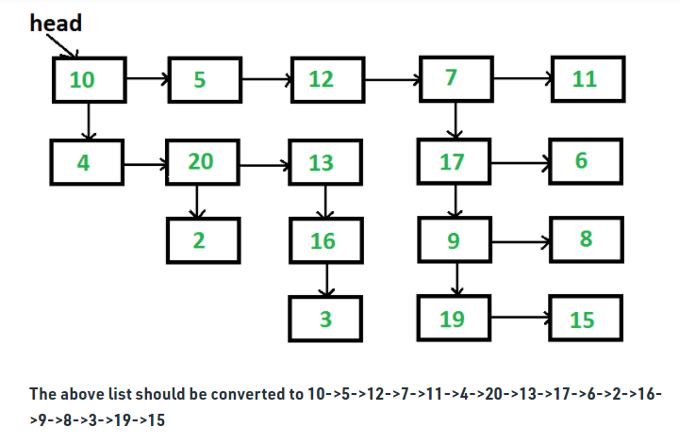

Q2) Perform the following tasks in a binary tree:

1. Create a binary tree by inserting new nodes in the tree using a non-recursive function
2. Create a binary tree by inserting new nodes in the tree using recursive function
3. Find the height of binary tree created
4. Check whether the tree created has any duplicate values.

Q3) Create a binary tree for the following expression: ***a+b*(c^d-e)^(f+g*h)-i***

Perform an inorder traversal of the tree to print this expression. Now, convert the given expression into postfix by performing a postorder traversal of the same.

Q4) Create a binary tree of 15 nodes. Now delete the following nodes from the tree:

1. Any leaf node
2. A node which has only one child
3. A node which has two children

Show an inorder traversal of the tree after every deletion.